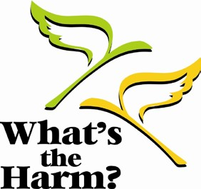
Registration Form

What’s the Harm? Conference 2022
13 Years of (R)evolution

October 17, 18, 2022 – Deer Creek Banquet Facility, Ajax

Name________________________________________________________________

Title: _______________________________________________________________

Agency: _____________________________________________________________

Phone: _____________________________ Fax: ____________________________

Email: _______________________________________________________

2022 Conference Plenary speakers:

- Dr. Gillian Kola PhD, MPH, Canadian Institute for Substance Use Research, University of Victoria
- Dr. Steven Hayle PhD, Associate Teaching Professor, Faculty of Social Science and Humanities Ontario Tech University
- Dr. Sajida Afridi MD FRCPC, Assistant Professor, Dept. of Psychiatry Queen’s University
- Angela Duckworth Ba Masshi Migizi Kwe BSW, RSW, Indigenous Health Promoter
- Yvette Perreault, MA Consultant, Former Director AIDS Bereavement and Resiliency Program of Ontario
- Stephanie Skopyk MN-PHcNP RN, NP(EC)

Conference Highlights

- Lived Experience Panel
- Panel on Sex Work and Human Trafficking
- Networking hour at the end of Day 1

Special Diet Requirements: ____________________________________________________________

____________________________________________________________________________________

A certificate of attendance will be provided.

Registration fee: $150 includes continental breakfast and lunch on both days.
Non-refundable if cancelled after 12 noon October 2, 2022

Please return the completed registration form by October 2, 2022 with a cheque made payable to the Durham Harm Reduction Coalition. Additional forms available at: www.durham.ca/harmreduction

Please mail/deliver payment and registration form to:
Attn: Durham Harm Reduction Coalition, C/O. Beth Whalen
John Howard Society of Durham Region
75 Richmond Street West, Oshawa, ON. L1G 1E3

